Git Version Control: Git is a distributed version control system used to track
changes of our project/source code.
Different people can contribute to same project and can track the changes using
git.
Basic Git Commands:
Git hub commands

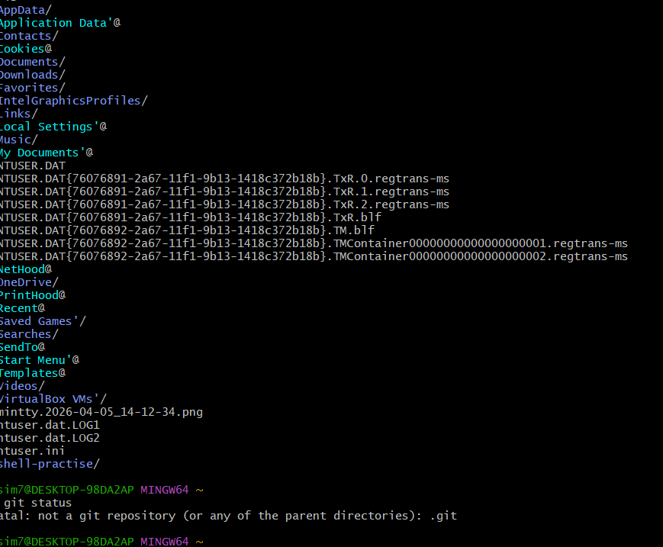

If you go inside .git and check you can see different files configured inside this directory
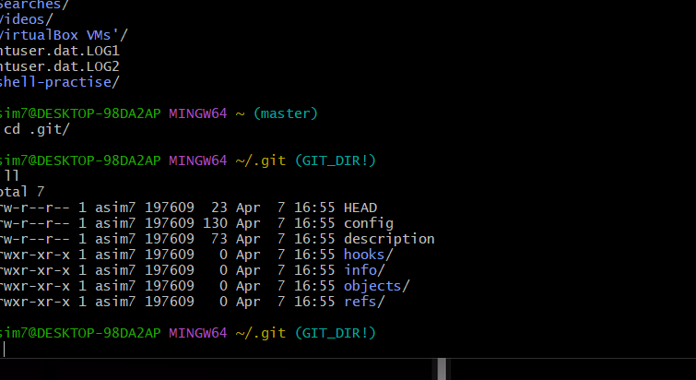

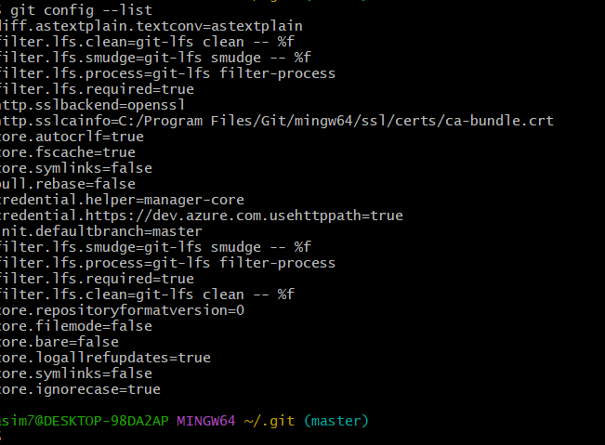

Untracking area to tracking area

git config --global user.name: this command can be used to change or configure
the username.
git config --global user.email: this command can be used to change or configure

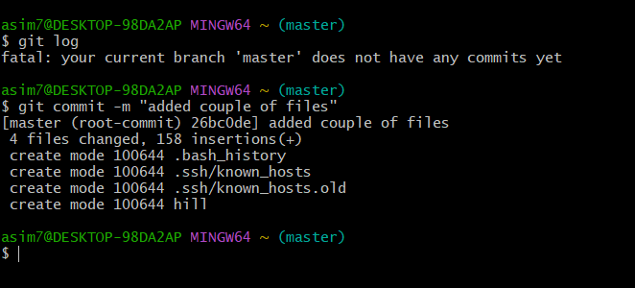

Commit ID
